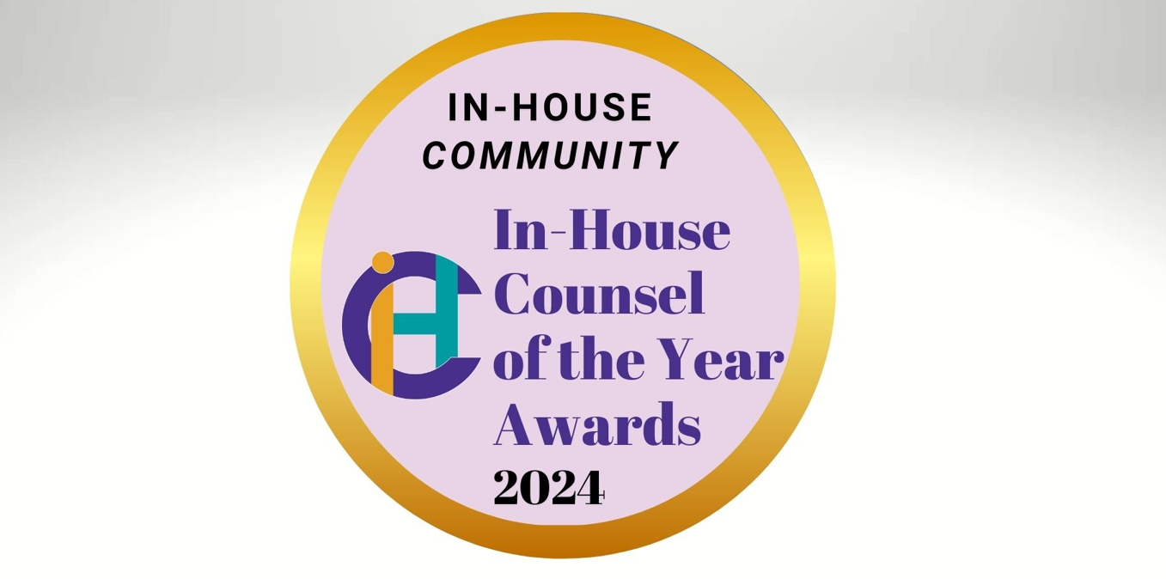
Submission and Nomination Form
In-House Counsel of the Year, 2024
Teams
PLEASE NOTE: IF YOU ARE A PRIVATE PRACTICE PROFESSIONAL, PLEASE USE THE BELOW FORM TO ONLY ADD INFORMATION ABOUT THE IN-HOUSE LEGAL NOMINEE.
- Choose the industry - for Industry Awards.
You can only choose 1. Tick/circle the choice.

- Aviation
- Banking
- Conglomerate
- Energy & Natural Resources
- Financial Services (ex-Banking)
- FMCG
- Insurance
- Life Science & Pharma
- Manufacturing & Engineering
- Property, Infrastructure & Logistics
- Retail
- Technology, Media & Telecom
- Travel, Hospitality & Leisure
- Choose the Practice for Best Practice Management Awards.
You can choose up to 2 only. Tick/circle the choice.

- Change Management
- Compliance
- Corporate Social Responsibility
- Diversity and Inclusion
- Innovation
- Integration (within your organisation’s departments)
- Small Team (four or less team members)
- Technology Integration
- Transactional

- Your/Nominee’s jurisdiction:
- Your /Nominee’s First Name:

- Your /Nominee’s Last Name:
- Name of your/ Nominee’s organisation:
- Your/ Nominee’s position/job title?
- Your/ Nominee’s official email ID?
- Name of the head of department
Please type 'self' if you are the head of department.
- Position/Job title of the head of department:
- Email ID of the head of department:

I would like to nominate:

My/Nominee’s country team.
My/Nominee’s regional team (please enter the region: _________________________)

- Explain below why this counsel / team should win (minimum 500 words) in the category you have chosen.
Demonstrate as many of the following as you can: Dedication; Innovation; Efficiency & Value; Integration; Encouragement & Improvement; CSR, Diversity, and Inclusion.
Include any work initiatives you have been part of or created within the last 12 months supporting your submission/nomination.
You may attach a document to this form for this answer.

- If possible, please also provide an endorsement from a member of the board, business unit or senior director, or the contact details of one who would be willing to be contacted for such. Please write their full contact details including name, position, email ID and phone number.

For any further questions and to submit your responses and any supporting documents, please email:

Ms. Toni Angeline
Toni.Angeline@inhousecommunity.com
Please include your/Nominee’s company name in the submission filename.
Submission Deadline: 14th June 2024.

KEY POINTS TO NOTE

- Confidentiality: We respect the confidentiality of the information shared with us. However, please note that all information provided to us may be published by InHouse Community Limited unless explicitly marked as confidential. To ensure the protection of sensitive information, we kindly request that any confidential details, including client names, deal or case values, or any other pertinent information, be clearly identified as CONFIDENTIAL. This should be done by highlighting the information in bold red. Your diligence in marking confidential matters will help us uphold the integrity and privacy of the information shared with us.
- It is crucial to submit your entries by the 14th of June 2024. The timetable for the judging process will be strictly followed to ensure a fair and thorough evaluation process. Your cooperation in adhering to these deadlines is greatly appreciated.
- Submission of Documents: Please ensure that the submission is sent to us in the same Word Document. Please name the document file with your company name, or the name of the nominated person in case of individual submissions.
- Why Submit? Submitting for awards boosts visibility, credibility, and morale. Recognition validates expertise, attracting collaboration and talent. Participation fosters excellence and innovation. Winning enhances the legal team's reputation and its strategic importance within the organisation – and helps in internal buy-in (legal tech, external legal services and more).

